**Exp 13 :**

1. **Write a Program to display the circular Progress Bar.**
2. **Write a Program to display the following Output.**

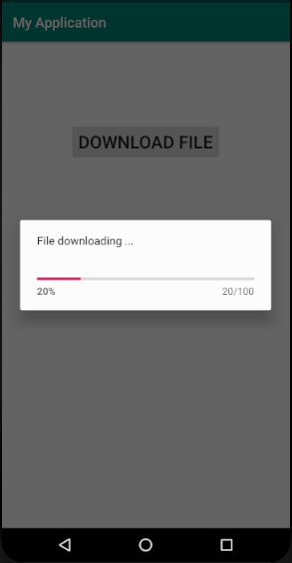

**Exp 14 :**

1. **Write a Program to show the following output.**

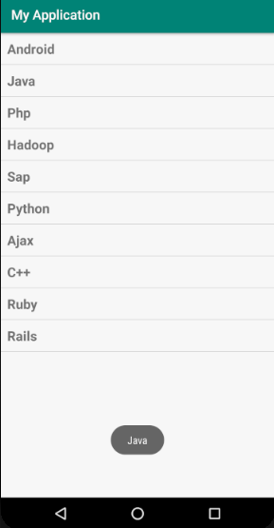

1. **Write a Program to create a Grid View and display the names of different Phones and Operating System and toast selected Phone**

**Exp 15 :**

1. **Write a Program to create 2 buttons as “Simple Toast” and “Custom Toast” on click of Simple Toast button normal toast must be displayed and on click of Custom Toast button a message with an image must be displayed.**
2. **Write a program to display three checkboxes and one button named “Order” as shown below. Once you click on button it should display simple toast along with items name and total price. Display custom toast on selection of checkbox…**

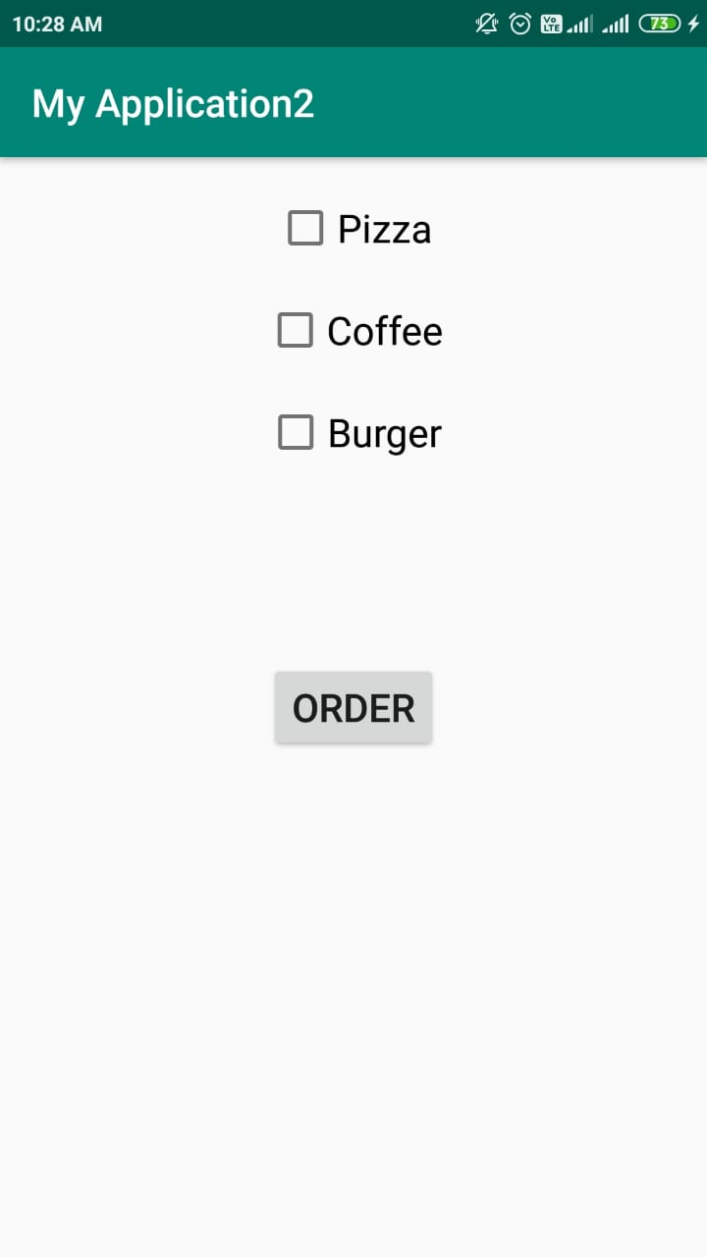

**Exp 16 :**

1. **Write a Program to display the time picker in spinner mode.**

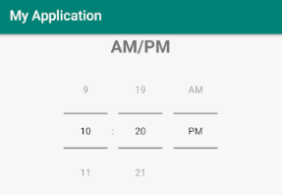

1. **Write a Program to display the time picker in 24 Hours format in spinner mode.**

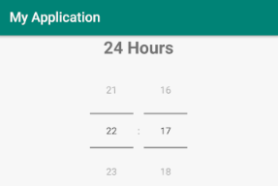

1. **Write a Program to display following output. Select and display date and time on click of “select date”, “select time” buttons respectively.**

**After Clicking select date button After selecting date**

